**ML ASSIGNMENT 1**

Snidhi Reddy Gudoor | 700745499 | sxg54990

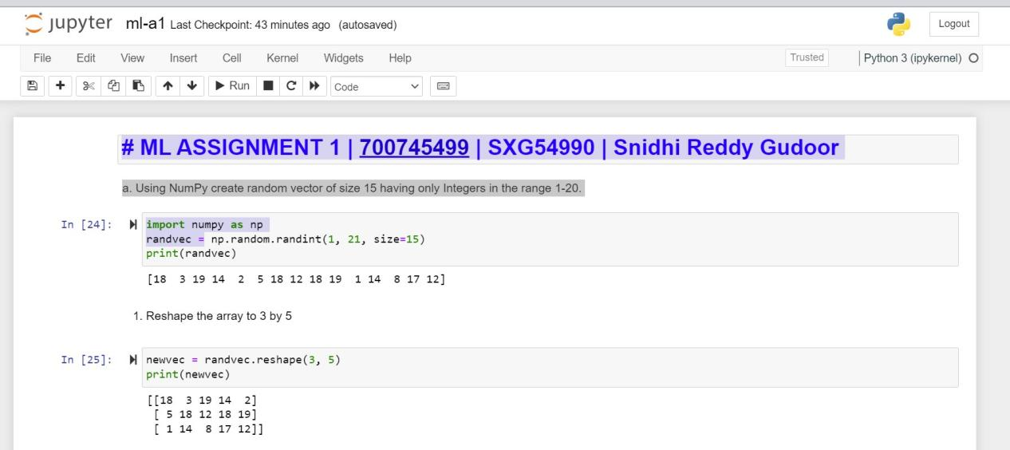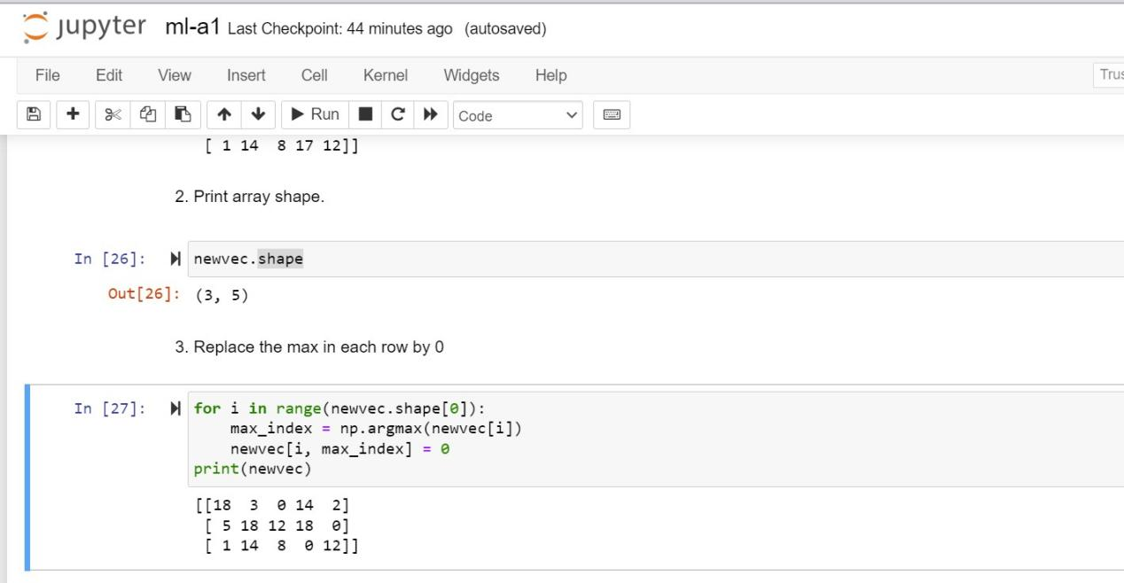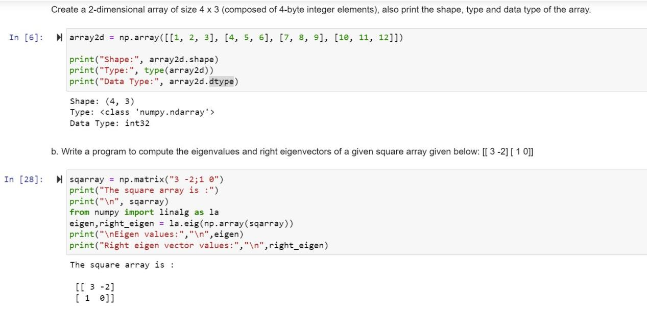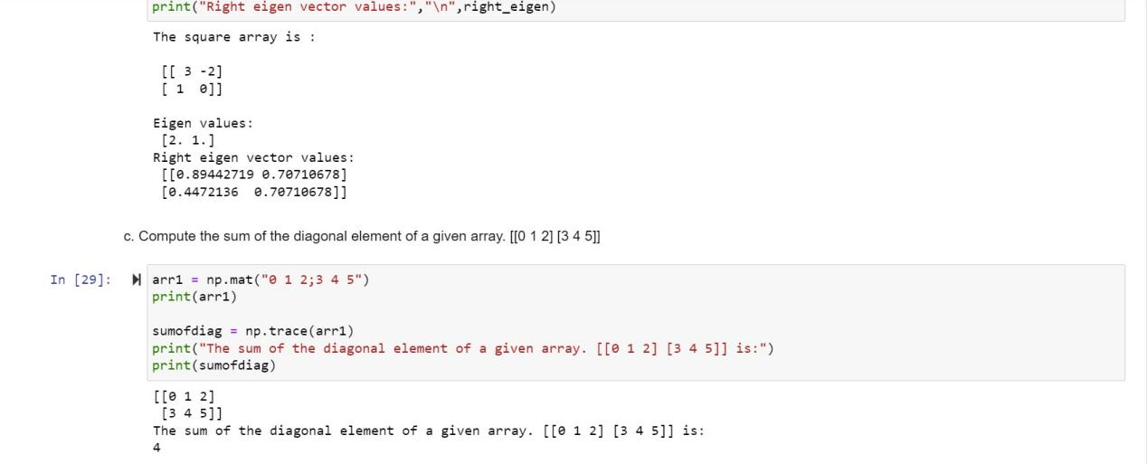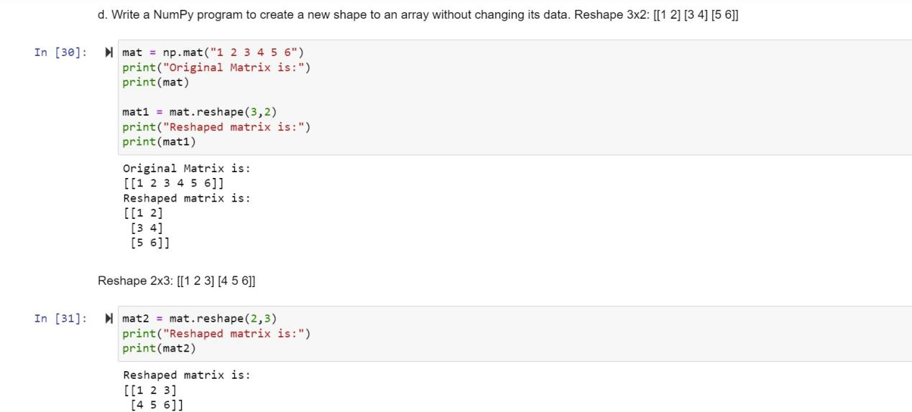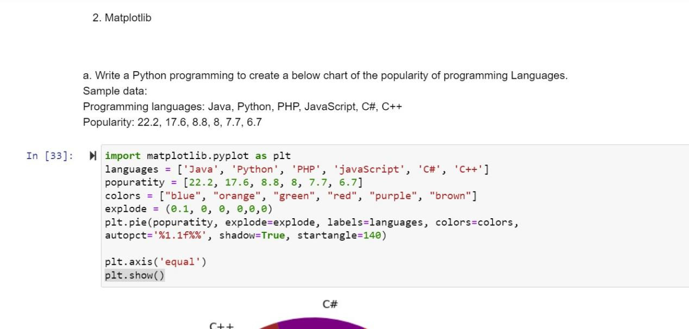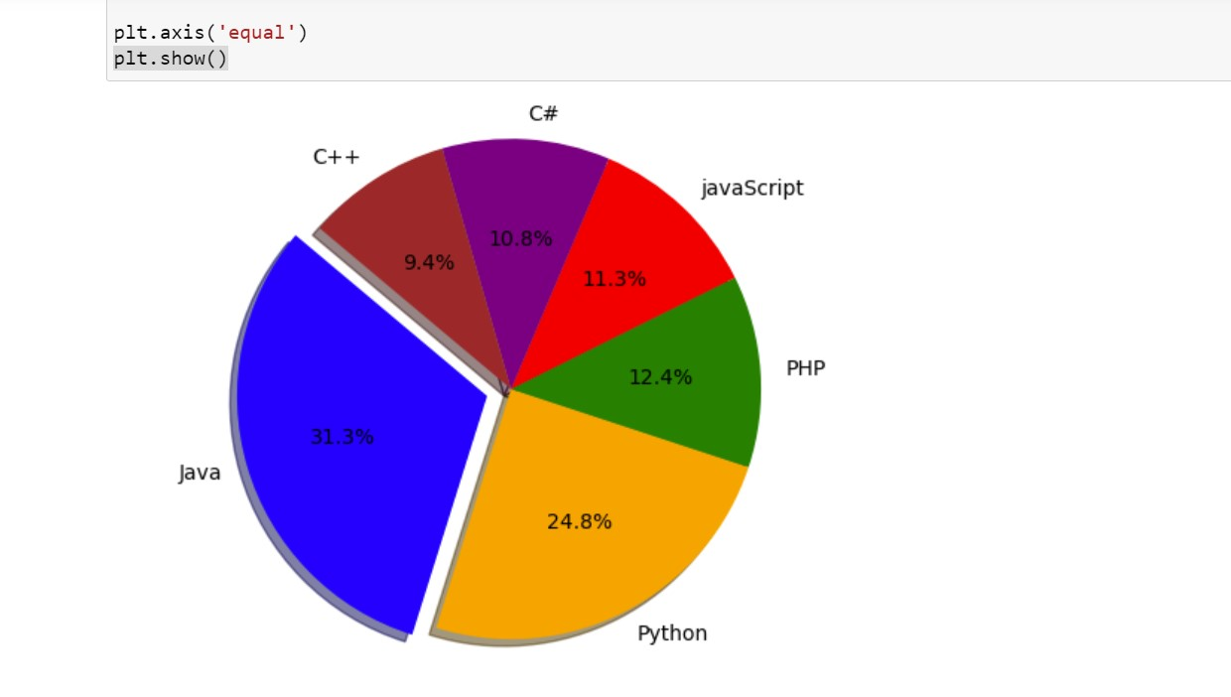

**GITHUB LINK :**

<https://github.com/snidhiee/ML1>

**VIDEO PRESENTATION:**

<https://drive.google.com/file/d/1CcLJxSSkLE9c7NuGen61scWz_xLNK8TI/view?usp=sharing>